Alerts:

* There are 3 types in js pop-up
* Simple Alert
* Confirmation Alert
* Prompt Alert

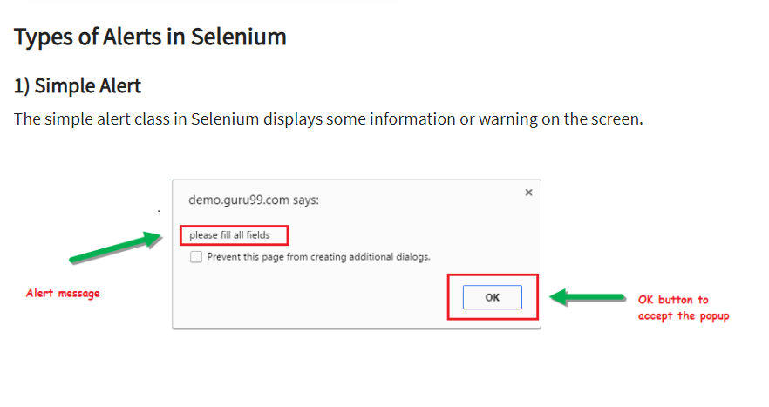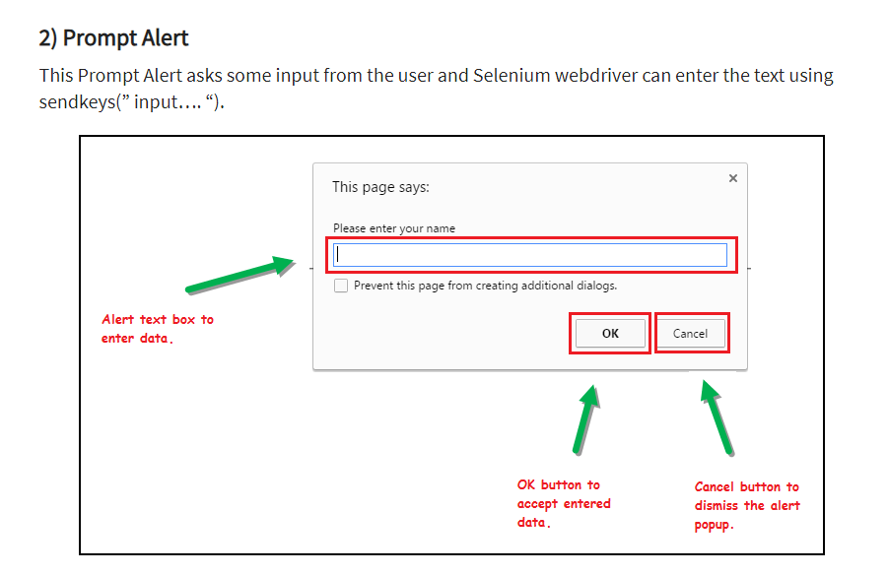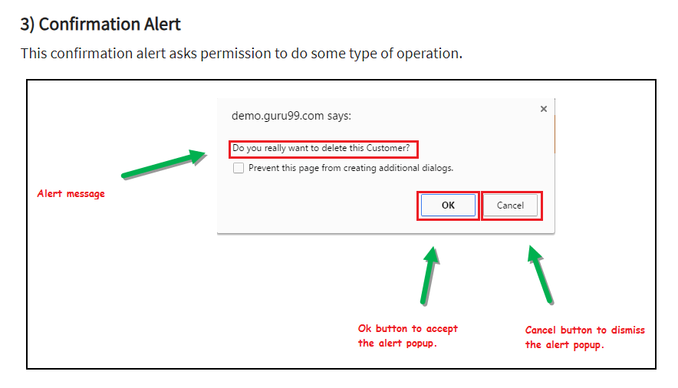

<https://demo.automationtesting.in/Alerts.html>

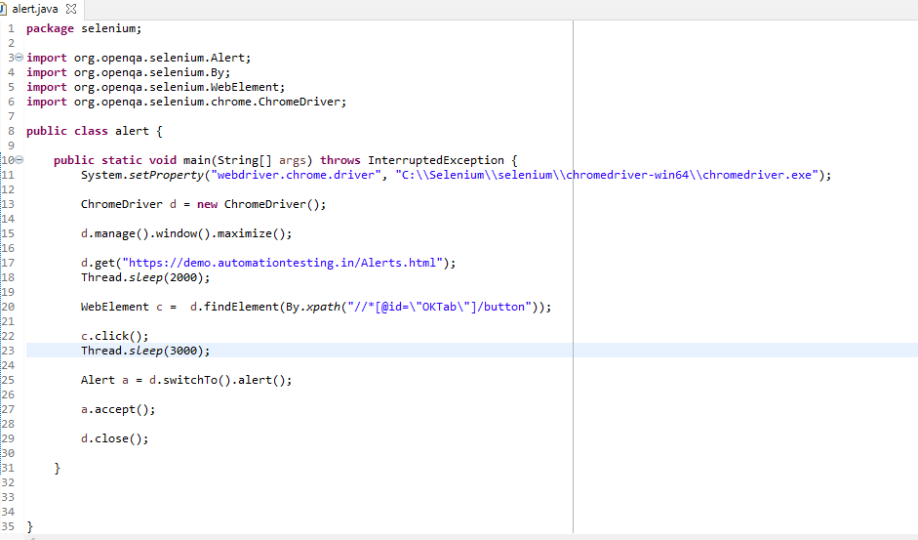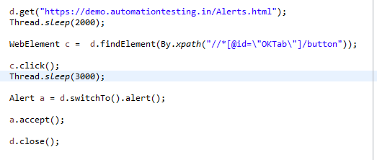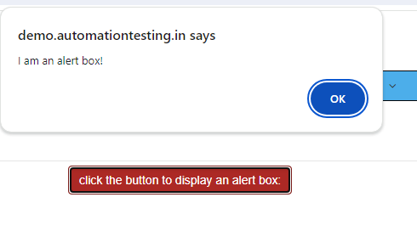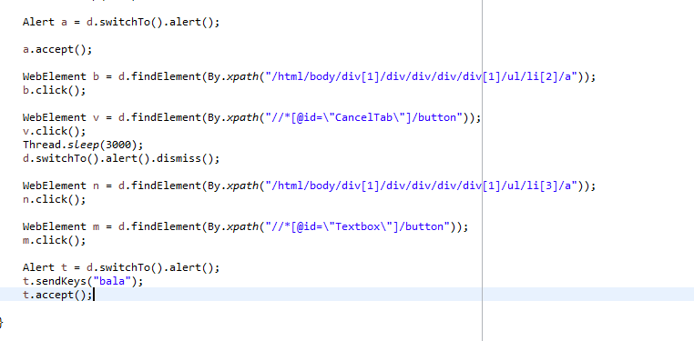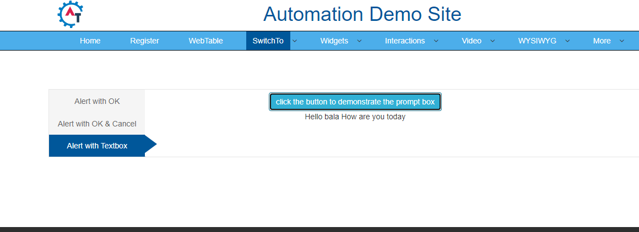

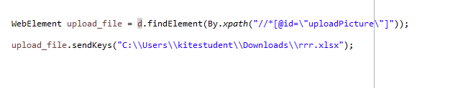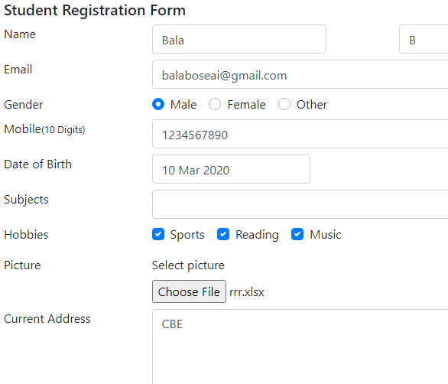

TASK

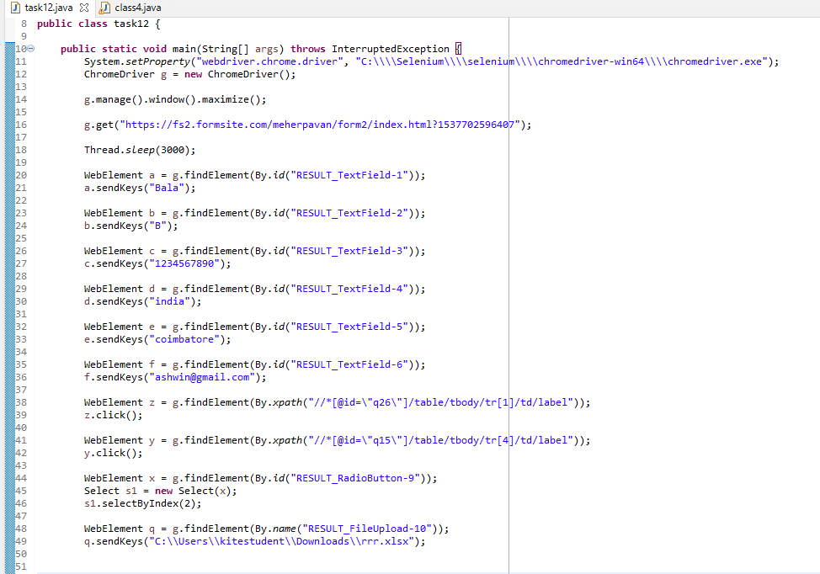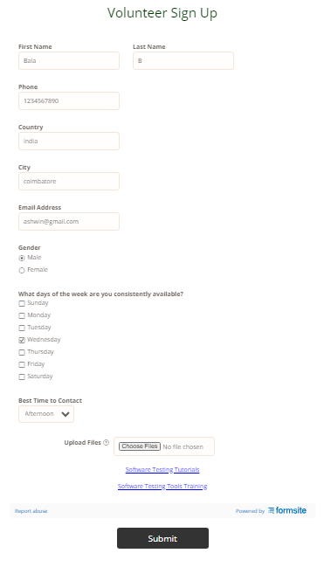

SCREENSHOT

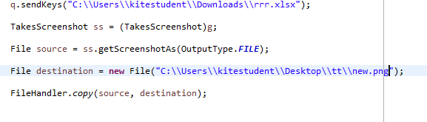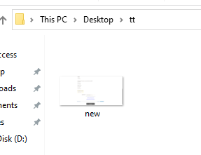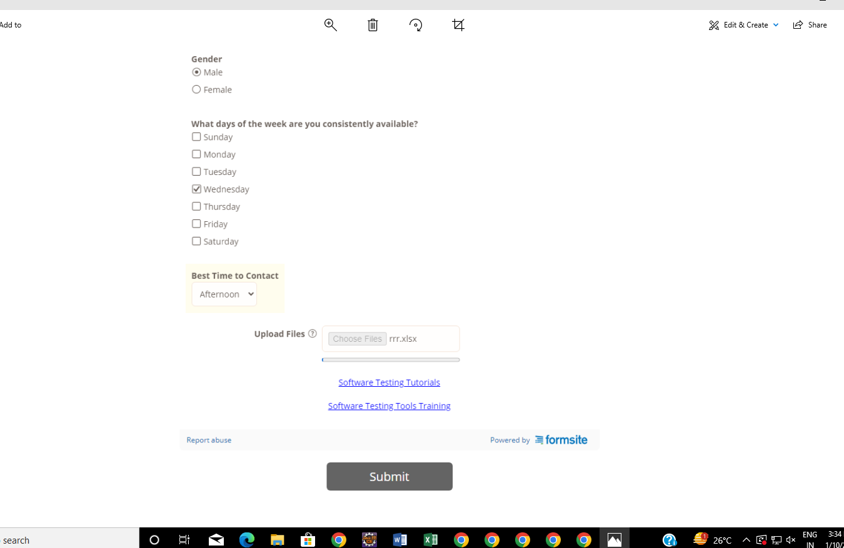

E3TakesScreenshot ss = (TakesScreenshot)g;

File source = ss.getScreenshotAs(OutputType.***FILE***);

File destination = **new** File("C:\\Users\\kitestudent\\Desktop\\tt\\new.png");

FileHandler.*copy*(source, destination);

|  |  |  |
| --- | --- | --- |
| 1 | sendKeys() | To enter the values in the cell |
| 2 | clear() | To clear the textbox value |
| 3 | Click() | To click the particular web Element |
| 4 | getCssValue() | To get the color / size/ font of the particular web element |
| 5 | findElement() | To get single web element. |
| 6 | findElements() | To get multiple web elements. |
| 7 | getText() | To get the text of the particular web element |
| 8 | getAttribute() | To get the text of the particular attribute(id,name,value,..etc) |
| 9 | getTagName() | To get the tag name of particular web element |
| 10 | getLocation() | To get the X axis and Y axis location of particular web element |
| 11 | getSize() | To get the size of particular webelement(textbox, text ,.. etc) |
| 12 | isDisplayed() | To Check whether the textbox is enabled to enter the text or not. |
| 13 | isEnabled() | To check whether the texttextbox is enabled to enter the or not |
| 14 | isSelected() | To check whether the radiobutton/dropdown is selected or not |
| 15 | submit() | To click on an element only if the type of the element is submit  Eg eg <inpu type=”submit” id=”s” |

Window Handling:

* It is used to move one window to another window

Syntax

d.WindowHandle() 🡪 single handle

Return type strings

d.WindowHandles() 🡪 multiple handels

Stores and returns in set strings

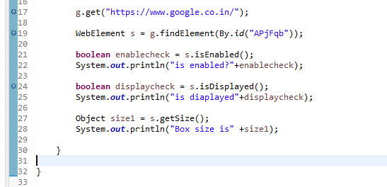

OUTPUT

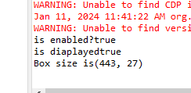

Parent Tab 🡪 d.get(“http:”)🡪code executing tab

Child tab from parent tab opens

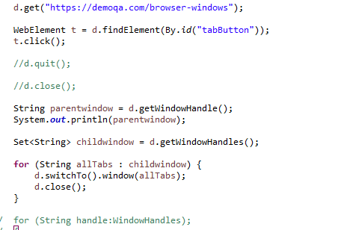

Closes all windows

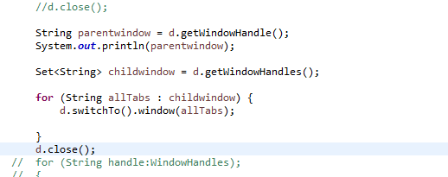

Closes only the child tab

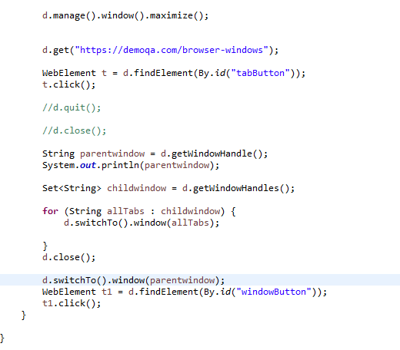

We should switch to the parent window.